1. **GET retrieve all resources**URL: <http://127.0.0.1:8001/api/v1/users>  
   Method: GET  
     
   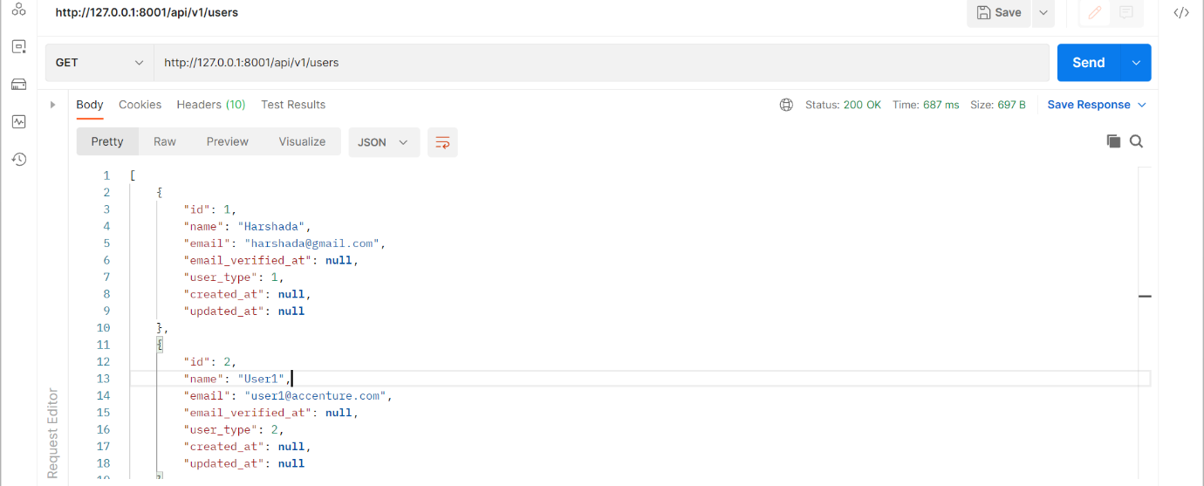
2. **GET retrieve one resource by id**URL: <http://127.0.0.1:8001/api/v1/showUser/1>  
   Method: GET  
     
   Graphical user interface, text, application

   Description automatically generated
3. **POST create one resource**   
   URL: <http://127.0.0.1:8001/api/v1/users>  
   Method: POST  
     
   Graphical user interface, application, Teams

   Description automatically generated
4. **PUT update one resource idempotent**  
   URL: <http://127.0.0.1:8001/api/v1/updateUser/1>  
   Method : PUT  
     
   Graphical user interface, text, application

   Description automatically generated
5. **PATCH update one resource**   
   Method : PATCH  
     
   Graphical user interface, text, application

   Description automatically generated
6. **DELETE remove one resource**URL: <http://127.0.0.1:8001/api/v1/deleteUser/1>  
   Method : DELETE  
     
   Graphical user interface, text, application

   Description automatically generated